**Python mini project-1 ( Number guessing game)**

# Problem Statement-

* Build a number Guessing Game in which the user selects a range. Assume the user selected a range from X to Y where both X and Y are integers.
* So a random number in that range is selected by the system where the user needs to guess the minimum number of guesses.

# Algorithm-

1. Initialization:
   * Define variables:
   * lower_bound (integer): The lower limit of the user-defined range (X).
   * upper_bound (integer): The upper limit of the user-defined range (Y).
   * secret_number (integer): The randomly chosen number within the range (generated by the program).
   * guess (integer): The user's guess for the number.

1. User Input:
   * Prompt the user to enter the lower bound (lower_bound).
   * Prompt the user to enter the upper bound (upper_bound).
   * Validate user input to ensure lower_bound is less than or equal to upper_bound.

1. Generate Secret Number:
   * Use a random number generator to select a secret number between lower_bound (inclusive) and upper_bound (inclusive).

1. Guessing Loop:
   * Start a loop that continues until the user guesses the correct number.
   * Inside the loop:
   * Prompt the user to enter their guess (guess).
   * Compare the guess with the secret_number:
   * If guess is greater than secret_number:
   * Print a message indicating the guess is too high.
   * If guess is less than secret_number:
   * Print a message indicating the guess is too low.

1. Check for Correct Guess:
   * After the comparison in step 4, check if guess is equal to secret_number.
   * If guess is equal to secret_number:
   * Exit the loop (user guessed correctly).
   * Print a congratulatory message and display the number of guesses it took the user.

1. Continue Loop:
   * If the guess wasn't correct, the loop continues back to step 4, prompting the user for another guess.

1. End Game:
   * Once the loop exits (due to a correct guess), the game ends.

**Pseudo code-**

START

import random

print("Welcome to the Number Guessing Game!")

print("charan")

while True:

lower_bound = int(input("Enter the lower bound: "))

upper_bound = int(input("Enter the upper bound: "))

if lower_bound > upper_bound:

print("Invalid range. Lower bound must be less than or equal to upper bound.")

else:

break

secret_number = random.randint(lower_bound, upper_bound)

attempts = 0

print(f"Guess the number between {lower_bound} and {upper_bound}!")

while True:

guess = int(input("Enter your guess: "))

attempts += 1

if guess < lower_bound or guess > upper_bound:

print(f"Please guess a number within the range {lower_bound} to {upper_bound}.")

elif guess < secret_number:

print("Too low! Try again.")

elif guess > secret_number:

print("Too high! Try again.")

else:

print(f"Congratulations! You guessed the number {secret_number} in {attempts} attempts.")

break

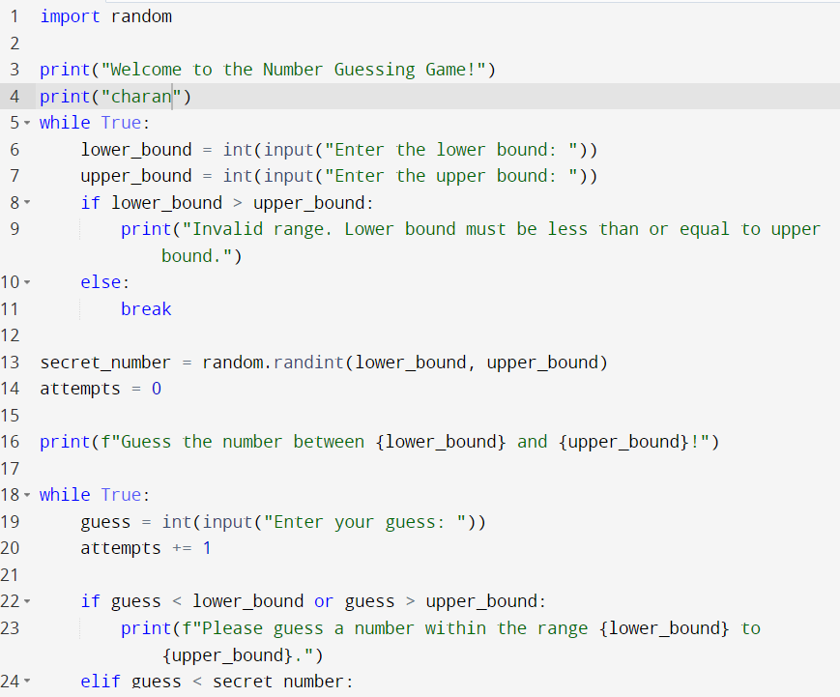

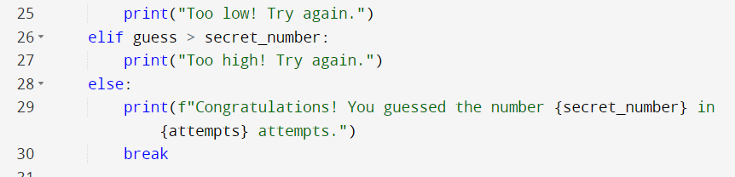

**OUTPUT :**

